Year 3 Mathematics

This week we are going to be using the BBC daily lessons website. These daily lessons are in conjunction with the white rose maths schemes that we use in school. These lessons will recap mathematics your child has already learnt and help reinforce key mathematical concepts needed for next year. These activities and websites are suggestions. If you would rather continue using your packs that were sent home before the school closure you are more than welcome to.

Monday 20th April
I can identify place value in 3-digit numbers and 4-digit numbers

Today you are going to identify ones, tens, hundreds and thousands from 4-digit numbers.

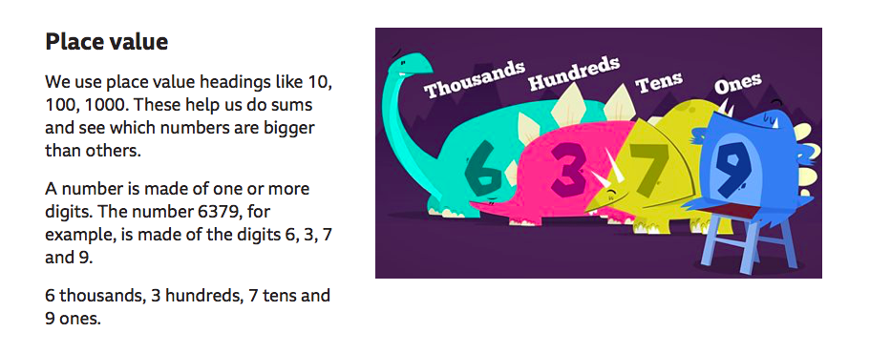
Click on the link below to learn all about place value and to try some place value activities
https://www.bbc.co.uk/bitesize/articles/zdgdwty

Offline activity
Can you create a 4-digit number using your imagination or a dice and identify what is the amount of each place value?
Can you ask an adult or someone at home to test you on your place value understanding? The adult or someone at home must say a 4-digit number and ask you what is each place value?

Tuesday 21st April
I can recognise place value in 3-digit numbers
To reinforce what you learnt yesterday you are going to identify the place value of each digit in a 3-digit number.
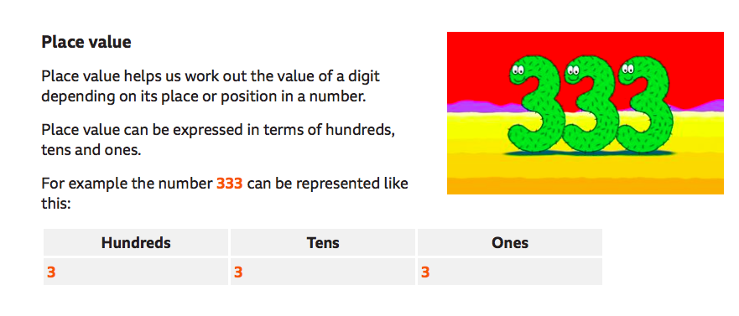
First have a look at the BBC Bitesize website and watch the videos on there to refresh your memory. Then try the activity.
https://www.bbc.co.uk/bitesize/articles/zmdpnrd
Next, click on the white rose maths link below to put your knowledge of place value to the test.
https://bam.files.bbci.co.uk/bam/live/content/zfnwjhv/pdf#sa-link_location=blocks&intlink_from_url=https%3A%2F%2Fwww.bbc.co.uk%2Fbitesize%2Farticles%2Fzmdpnrd&intlink_ts=1587130441378-sa
Finally, you can play the place value snakes and ladders game with someone at home using the link below
https://bam.files.bbci.co.uk/bam/live/content/z7m9kmn/pdf#sa-link_location=blocks&intlink_from_url=https%3A%2F%2Fwww.bbc.co.uk%2Fbitesize%2Farticles%2Fzmdpnrd&intlink_ts=1587130463027-sa

Wednesday 22nd April
I can compare 3-digit numbers

Today you are going to be comparing 3-digit numbers using the more than, less than and equals to symbols.
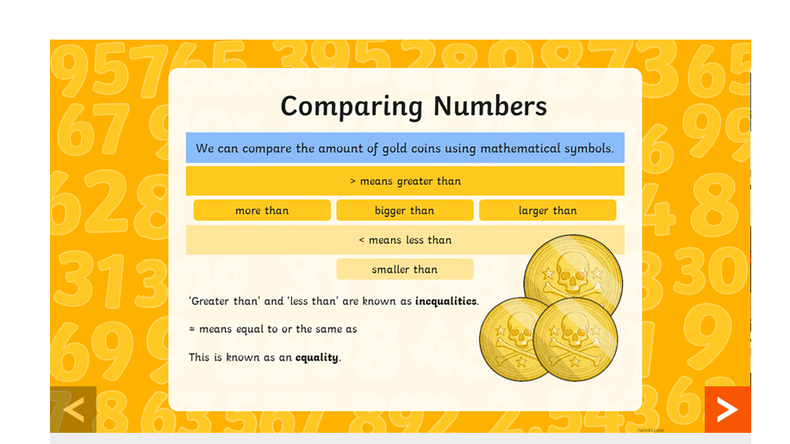
Use the BBC Bitesize link below to learn all about how to compare 3-digit numbers.
https://www.bbc.co.uk/bitesize/articles/zhpq7nb
Now you have watched the PowerPoint on the BBC website. Now try some activities.

Activity 1
You must roll a dice to create 2-digit and 3-digit numbers and place them in the correct boxes. The link is below
https://bam.files.bbci.co.uk/bam/live/content/z4wrcqt/pdf#sa-link_location=blocks&intlink_from_url=https%3A%2F%2Fwww.bbc.co.uk%2Fbitesize%2Farticles%2Fzhpq7nb&intlink_ts=1587131052833-sa
Activity 2
Now try this pirate game me matey! With someone else at home, roll a dice to create 3-digit numbers and create a pirate sentence. The link is below
https://bam.files.bbci.co.uk/bam/live/content/znrsf4j/pdf#sa-link_location=blocks&intlink_from_url=https%3A%2F%2Fwww.bbc.co.uk%2Fbitesize%2Farticles%2Fzhpq7nb&intlink_ts=1587131328588-sa

Thursday 23rd April
I can order numbers up to 1000
Today you are going to order numbers up to 1000. You will have a range of 3-digit numbers and you must order them in the correct order from smallest to largest.
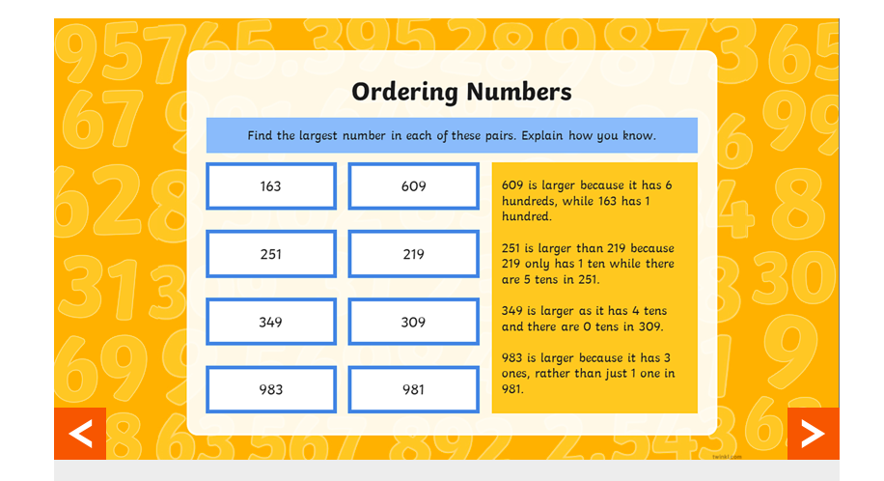

Have a look on the BBC Bitesize link below to find your activities and learn all about ordering numbers up to 1000.
https://www.bbc.co.uk/bitesize/articles/zb86t39

Now try these activities.

Activity 1
With someone else at home, create 3-digit numbers at random using the number cards on the activity sheet. Then create a number line and place them in the correct order from smallest to largest. The link is below.
https://bam.files.bbci.co.uk/bam/live/content/zh3dwty/pdf
Activity 2
Now try and find out the answer to the funny joke in this activity. With an adult, answer the questions and place the 3-digit numbers in the correct order from smallest to largest. The link is below.
https://bam.files.bbci.co.uk/bam/live/content/zbdthbk/pdf#sa-link_location=blocks&intlink_from_url=https%3A%2F%2Fwww.bbc.co.uk%2Fbitesize%2Farticles%2Fzb86t39&intlink_ts=1587132876235-sa

Friday 24th April
I can answer challenge questions
Today you are going to answer some challenge questions based on what you have learnt this week.
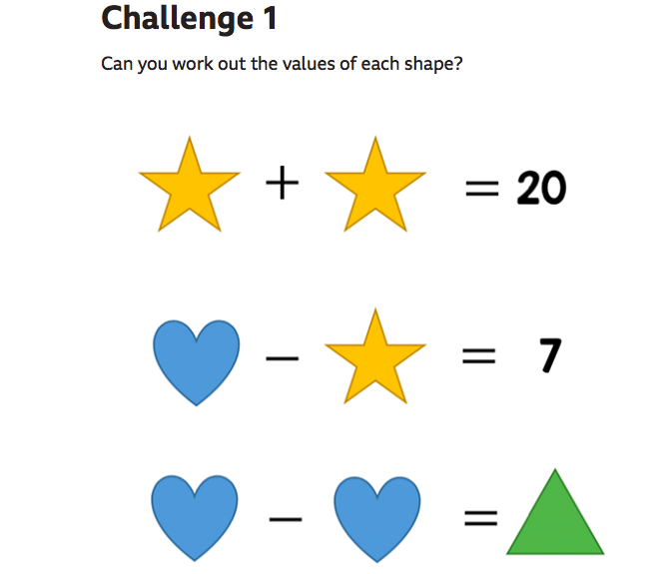

Have a go on the BBC website to answer these challenge questions. The link is below.

https://www.bbc.co.uk/bitesize/articles/zbqrcqt

