Week 1 Summer Term

Mathematics
Year 3 Mathematics – This week we are focusing on fractions – Week 1 (not the summer week 1). The first lesson is unit and non-unit fractions: https://whiterosemaths.com/homelearning/year-3/

Offline activities:

Can you gather your shoes and create fractions of how many shoes are white or how many shoes have the colour red in it?

Can you explain what you would add to these fractions to make them whole:
- I have $\frac{5}{18}$ pieces of my Easter egg, how many more pieces do I need to make it a whole egg?
- I have $\frac{5}{9}$ slices of yummy pizza, how many more pieces of pizza do I need to make a whole?
- If I have $\frac{4}{11}$ pieces of pear and add 8 more pieces of pear, have I made a whole? How do you know?

Can you create random fractions and place them on a number line from 0 to a whole?

Year 4 Mathematics – This week we are focusing on tenths – Week 1 on the white rose website (not the summer week 1). The first lesson is recognise tenths and hundredths: https://whiterosemaths.com/homelearning/year-4/

Offline activities:

Can you split these fractions up into tenths and hundredths part wholes? For example: $\frac{27}{100}$ would be $\frac{2}{10}$ and because we have 7 ones left $\frac{7}{100}$

Now try these:

- $\frac{56}{100}$
- $\frac{16}{100}$
- $\frac{99}{100}$
- $\frac{21}{100}$
Are these true or false? How do you know?
- $\frac{7}{10 }$ equals 0.72

- $\frac{6}{10 }$ equals 0.6

- $\frac{1}{10 }$ equals 0.01

- $\frac{9}{10 }$ equals 0.89

PE

Make sure you are as active as you can be! It is so important to keep active as this makes you feel more positive and helps give you amazing ideas for the rest of your learning. Why not tune into Joe Wicks on YouTube (the body coach) at 9am every morning from Monday to Friday. You could also try some yoga. On this website is a link with YouTube videos of yoga for children, these include cosmic yoga https://awakeandmindful.com/best-kids-yoga-videos-on-youtube/.

For offline activities, why not create your own dance moves from our wake and shake along to a song or create your own fitness course from our Joe Wicks lessons.

Music
This week you can learn about timbre. You can learn all about timbre with Mylene Klass : https://www.youtube.com/watch?v=RzE55yauSUo.

For offline activities, can you listen to any music and write down some words of what it sounds like? It may sound smooth, sound tinkling, sound scratchy, sound bright, sound heavy or sound dull.

Art
This week you are going to look at a piece of art called ‘Jericho’ created by Anselm Kiefer. Have a look at this photograph of his creation. What materials do you think he used? What is he trying to build? Why do you think he made this?

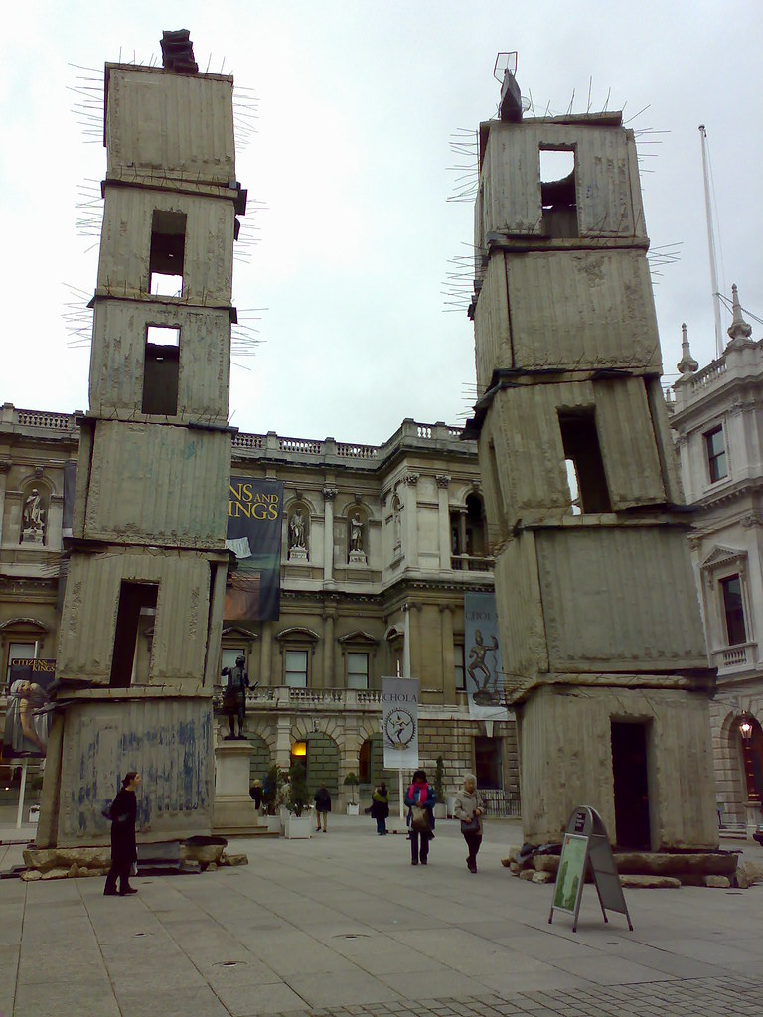

Can you now think of your own creation that you could make? What materials would you use? What would you make and why?

Offline activities
Can you find any piece of fruit or vegetable and sketch out what you see? Can you move the object around to create different parts of shading?

Geography

This week can you explain and describe what ‘settlement’ means? Can you imagine you are a settler from a different country? You must explain what you think you would need to settle in a new place, this may include what land you will choose to settle on? What food and drink you will have? How you will find trade? Here is a really good website to help you explain your ideas https://www.bbc.co.uk/bitesize/topics/zx72pv4/articles/zrbvjhv

Offline activities
Can you create a map of your house and create symbols to show where things are in your house?
Computing

This week can you remember what an algorithm is? Use this website https://www.bbc.co.uk/bitesize/topics/zs7s4wx/articles/zqrq7ty to help you create your own algorithm for creating a recipe or finding something in your house.

Offline activities
Human beebots! Can you with someone at home, become a beebot and give them instructions to find something in your house? Explain how many steps they must take and how many times they have to turn. Try and estimate how many steps you think it may take.

DT

Can you design your very own kite? You can plan out how it will work and describe why you think it will work. Have a look online to find some ideas of kite shapes and describe the different properties of the shapes to someone at home.

