PE FLE Y1/2 Hockey
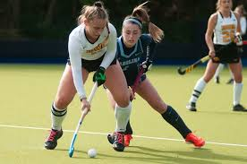 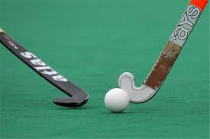 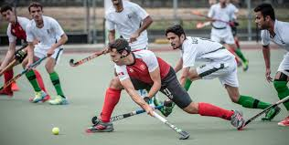 Our Endpoint
To take part in a mini hockey tournament.
Forever Facts  Regular sport and exercise help us to stay healthy.  The aim of the game is to score goals past the opposition’s goalkeeper.  A competitive game is usually 70 minutes, in two halves.  The team with the most goals wins.  The foot of the hockey stick has a flat side and a curved side.  The ball must be hit with the flat side of the hockey stick.  In competitive field hockey matches, players wear shin pads and a gum shield for protection.  Goalkeepers are heavily padded to allow them to block the ball with their body if they need to.  Common fouls include raising the hockey stick above waist height and striking an opponent or their stick with your stick. | Exciting Books | Subject Specific Vocabulary  field hockey A sport played on a grass field with a ball by two teams of eleven players  exercise to be physically active  control to be in charge of your body movements  coordination the ability to use different body parts together smoothly  balance The distribution of weight to ensure that we are able to stand upright and steady  defend Preventing someone from passing or dribbling the ball or scoring.  attack Dribbling or passing the ball in order to create an opportunity to score.  Skills  Explore different ways of moving a ball.  Understand the importance of stopping a ball.  Talk about how to exercise safely.  Begin to understand some concepts of game.  Begin to show some understanding of simple tactics.
SMSC
Social – Cooperating well with others
Spiritual – Sense of enjoyment and fascination in our learning
Cultural – Willingness to participate in sporting opportunities

