**Home learning for class lynher week beginning 20/04/2020**

**Maths**

We will be following the BBC lessons. The main link is <https://www.bbc.co.uk/bitesize/dailylessons> You then click on the appropriate year group. They have been written in conjunction with the maths scheme we use and they are recapping and reinforcing key things that will be needed next year.

Please see the corresponding year group file for more information including offline ideas. As always if you are finding it too difficult, please don’t stress. There are always times tables to practice.

**English – GPS focus: using commas in sentences to clarify meaning**

Suggested online activity:

Complete the activity and understand how commas can change the meaning of a sentence.

<https://www.bbc.co.uk/bitesize/topics/zvwwxnb/articles/zc773k7>

Suggested offline activities:

Can you create a sentence with and without commas which changes the meaning? E.g. A panda eats shoots and leaves or a panda eats, shoots and leaves! How many can you come up with?

**Reading: Retrieval questions.**

When reading your book, can you retrieve a sentence that explains how a character is feeling/behaving? Can you identify the features that make your book fiction or non-fiction?

**Science**

Our focus is dissolving

Key vocabulary –

* Dissolve - to become broken up or absorbed by something or to disappear into something else
* Solution - a specific type of mixture where one substance is dissolved into another

Can you set up your own experiment to find out which substances dissolve? Can you experiment to see if you can find a way of speeding up the rate of dissolving? **Make sure you get parental permission for anything you set up!**

Here is a copy of our science planner to help.

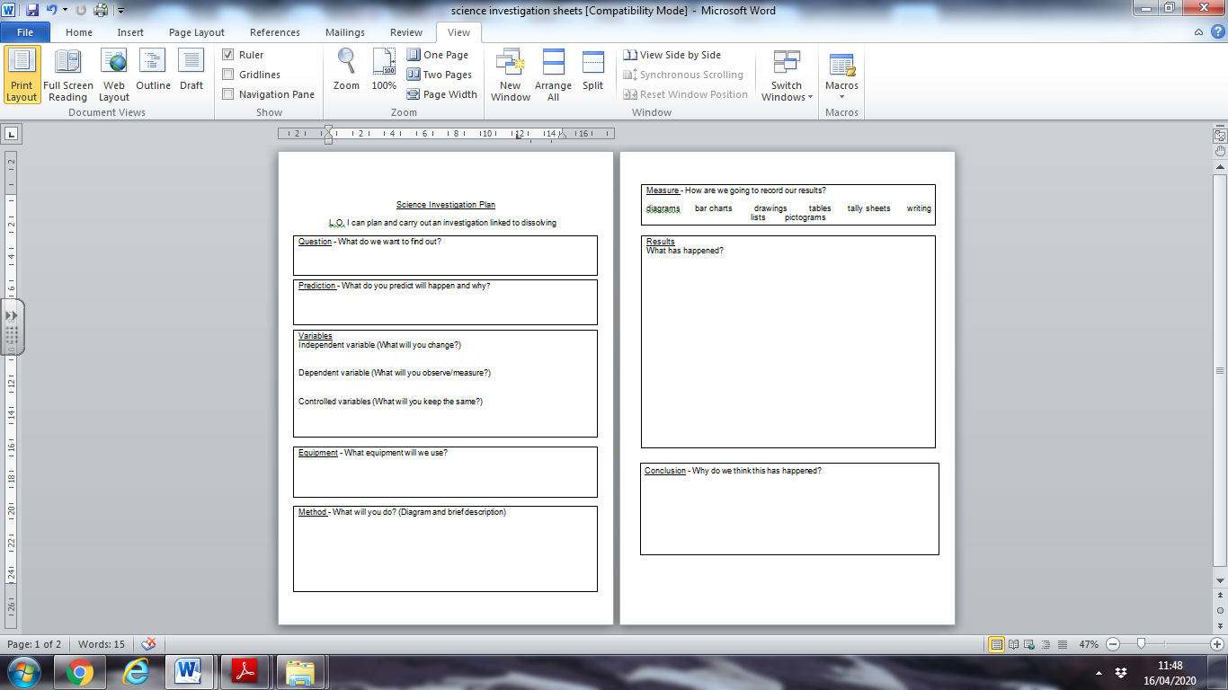

You can also explore dissolving online at <https://www.bbc.co.uk/bitesize/topics/zcvv4wx/articles/zpbdpbk>

**PE**

Be active as much as possible, it’s good for both your physical and mental health. Online activities include watching (and of course joining in with) Joe Wicks (The Bodycoach) – he is live on youtube every weekday morning at 9 but you can watch the previous videos at any time. Cosmic yoga videos on youtube are great for stretching, the stories may be aimed at a lower age but the nature of the activity is good.

Offline – focus on your throwing accuracy. If you have outdoor space, see how far away from a hoop/bucket you can get and still throw a ball accurately into it. If you are inside you may need to be a little more creative and ensure nothing gets broken!

**DT**

There is a national programme set up to introduce children to the world of engineering.



I will upload all of the resources but you can also find them for yourself at [www.leadersaward.com](http://www.leadersaward.com)

It would be wonderful if you could use your imagination to find a problem to solve at home and come up with your own way to solve it. Your parents can enter your ideas following the information on the website (it does require registration for that). I will leave this on for a few weeks so you can really get to grips with it.

**Computing**

Continue to learn to touch type. This could be a very handy skill for the future.

<https://www.bbc.co.uk/bitesize/topics/zf2f9j6/articles/z3c6tfr>

Or/and

Learn about digital images at <https://www.bbc.co.uk/bitesize/topics/zf2f9j6/articles/z2tgr82>

**Art**

Each week there will be a skill to practice. Be as creative/imaginative as you can.



I bet you will be amazing at this!

**Music**

Our focus this week is rhythm

Rhythm - A pattern of long and short notes (like the pattern of words in a song).

Online - Watch and join along with this interactive video from professional musician Mylene Klass learning about rhythms.

<https://www.youtube.com/watch?v=8XXmBlTadys>

Offline - Can you create, note down and play rhythms

**Geography**

Now you have identified your favourite place, can you describe it? Either in writing or orally? Why is special to you? What geographical (or historical) features are there?

**British Values** – **Mutual Respect**

Discussion: Are our hospitals too busy?

Our NHS is a free service that helps us when we are ill or injured. Wherever we are from and whatever experiences we have, the NHS treats us all equally.

**RE Easter**

Find out some more about the Easter story and how Christians remember it at the festival of Easter.

There are lots of ways that you could do this. For example, you could look in a Bible, speak to a Christian friend or look at this helpful website.

https://www.bbc.co.uk/bitesize/topics/ztkxpv4/articles/z4t6rj6 Now write down 5 fascinating facts that you have found out about Easter.

**Offline activity:**

**Stations of Cross**

Read this information sheet about the stations of the cross. Remember as much information as possible. You will need to know it for some RE and Art work later!

**What are the ‘Stations of the Cross?’**

They are 14 artistic images that show Jesus’ journey as he walked to his crucifixion and was then taken to his tomb.

**Where are the Stations of the Cross?**

Lots of churches in the UK have pictures or sculptures of the fourteen stations.

**How do Christians use them?**

Many Christians look at the Stations of the Cross on Good Friday to help them think about Jesus’ journey. By thinking about Jesus Christ’s last day, many Christians hope to remember and understand Jesus’ suffering. The Stations of the Cross help Christians to think deeply and pray.

**The stations are:**

1. Jesus is sentenced to die  
2. Jesus takes his cross and begins to carry it  
3. Jesus falls down  
4. Jesus meets his mother, Mary  
5. A man named Simon helps Jesus carry the cross

6. A woman named Veronica wipes Jesus’ face  
7. Jesus falls down a second time  
8. Jesus meets the three women of Jerusalem  
9. Jesus falls for the third (and final) time.

1. Jesus’ clothes are taken away
2. Jesus is nailed to the cross
3. Jesus dies on the cross
4. Jesus’ body is taken down from the cross.
5. Jesus’ body is placed in a tomb

Some Christians like to include a 15th Station showing Jesus’ resurrection.

Choose one Station of the Cross that you think a Christian might say shows a very important part of the Easter story. Make it into your own piece of artwork.

**PSHE – Celebrating diversity.**

Create a poem for the ‘perfect person’ using these ingredients. Is there such thing as a perfect person? Discuss.

