Year 4 mathematics
This week we are going to be using the BBC daily lessons website. These daily lessons are in conjunction with the white rose maths schemes that we use in school. These lessons will recap mathematics your child has already learnt and help reinforce key mathematical concepts needed for next year. These activities and websites are suggestions. If you would rather continue using your packs that were sent home before the school closure you are more than welcome to.

Monday 20th April
I can identify place value in 4-digit numbers
Today you are going to identify the place value in 4-digit numbers.
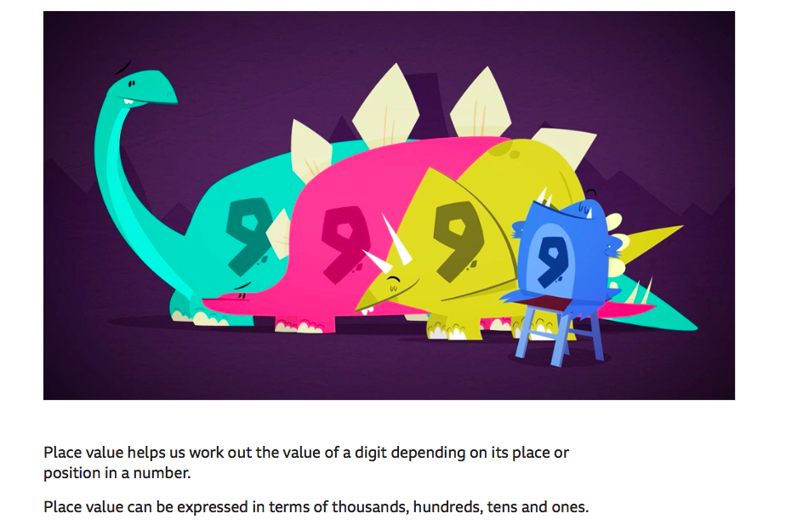
On the BBC website, there are 2 videos for you to watch and learn all about place value of 4-digit numbers. Then there are a few activities for you to try. The link is below.
https://www.bbc.co.uk/bitesize/articles/zhnrcqt

Offline activity
Place value battle
What to do:
Each player should draw a set of four squares next to each other on a piece of paper, as if you were going to write a four-digit number.
Version 1:
Players take it in turns to roll a die and write it on their chosen place value square. The aim of the game is to be the player with the greatest four-digit number at the end of the game. Good luck!

Tuesday 21st April
I can find 1000 more and less
Today you are going to find 1000 more and less using your amazing place value understanding.
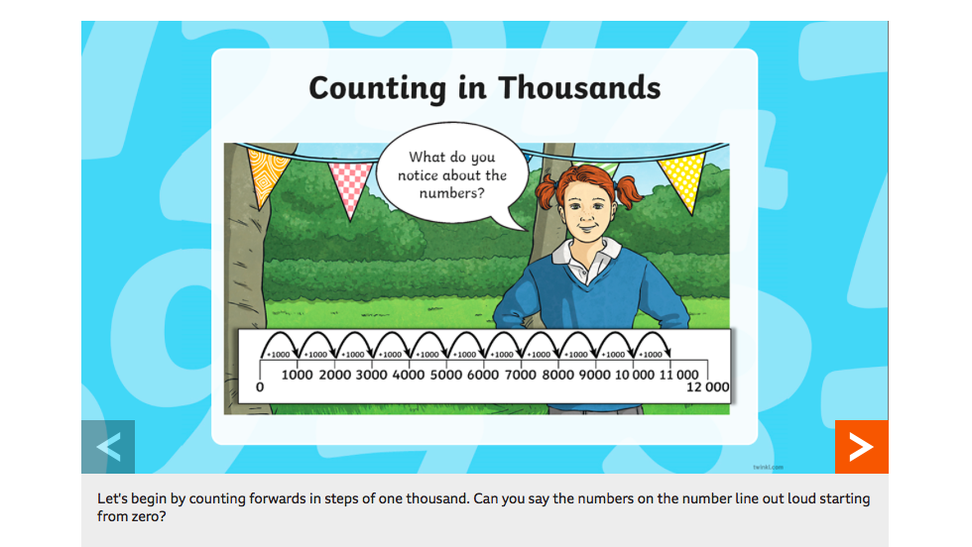
Go on to the BBC bitesize website and watch the PowerPoint on finding 1000 more and less. The link is below.
https://www.bbc.co.uk/bitesize/articles/zd9hpg8

Now try and activity of catching a duck, you must find 1000 more and less of the amount on the duck. The link is below.
https://bam.files.bbci.co.uk/bam/live/content/zhxrcqt/pdf

Wednesday 22nd April
I can round to the nearest 10, 100 and 1000
Today you are going to be rounding to the nearest 10, 100 and 1000.

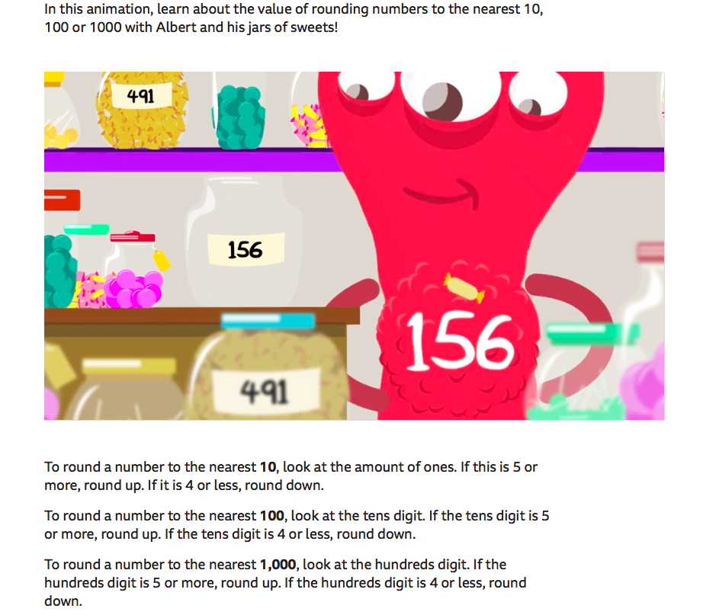

Now have a look on the BBC bitesize website and watch both of the videos to remind yourself of how to round to the nearest 10, 100 and 1000. Then try some of the activities. The link is below.
https://www.bbc.co.uk/bitesize/articles/zjf492p

Offline activity
Rounding pairs activity
Have a go at this fun rounding game from Maths with Parents.
- Create cards with the numbers: 1000, 1326, 1500, 1504, 2500, 3000, 3762, 3800, 3850, 3900 on them.
- Shuffle them and spread them about, face down.
- Players take it in turns to turn over two cards and show them to everyone.
- If one number can be rounded to the other then you have made a pair (eg, 1504 can be rounded to 1500.)
- You must say if you have rounded it to the nearest ten, the nearest hundred or the nearest thousand.
- If you have made a pair you keep it.
- If you have not made a pair, turn the cards back over and put them in the same position as before.
- The person with the most pairs at the end wins.

Thursday 23rd April
I can recognise negative numbers
Today you are going to identify negative numbers and explain where to place these numbers on a number line.
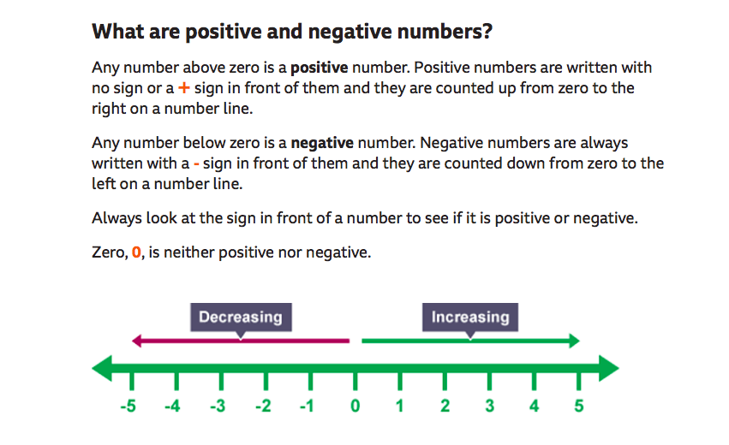

Go on to the BBC bitesize website and watch the videos on negative numbers. After you have reminded yourself of negative numbers have a go at their activities. The link is below.
https://www.bbc.co.uk/bitesize/articles/zkmv382

Offline activities

An idea to try:
- In an open space, use post-it notes to label positive and negative numbers from 10 to -10; children could be asked to separate numbers on the number line (whichever they choose, in random order,) whilst someone else records each number that they move to.
- Afterwards, decide on which numbers were the highest and which were lowest.
- The number scale could be changed to represent different things, eg: a thermometer, a lift, a swimming pool or a mountain. Once the children are confident, the scale could be changed to help them understand larger positive and negative numbers.
Friday 24th April
I can answer challenge questions
Today you are going to answer some challenge questions based on what you have learnt this week.
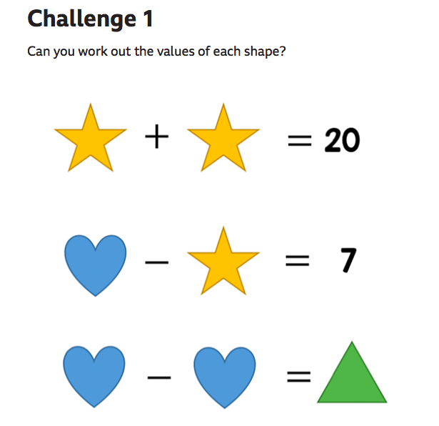
Have a go on the BBC website to answer these challenge questions. The link is below.
https://www.bbc.co.uk/bitesize/articles/zv8v382

